Using flightraja.com
Step 1

Log on to http://agent.flightraja.com

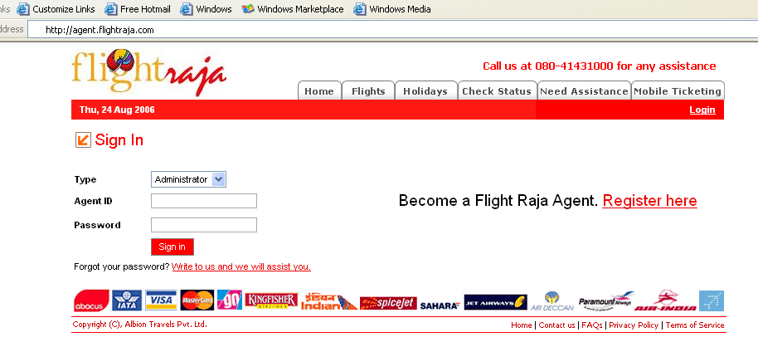
Step 2

Sign into your account with user type as Administrator

Note

Your agent ID is your e-mail id or Mobile number registered & our password is either registered by you or given to you by us on telephone. It is recommended that after you have activated your account, you may change your password for extra security.

Step 3

Search and Book Flights Now.

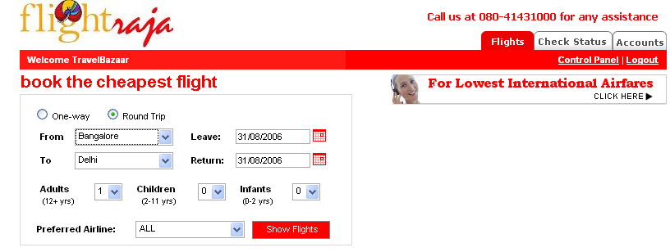

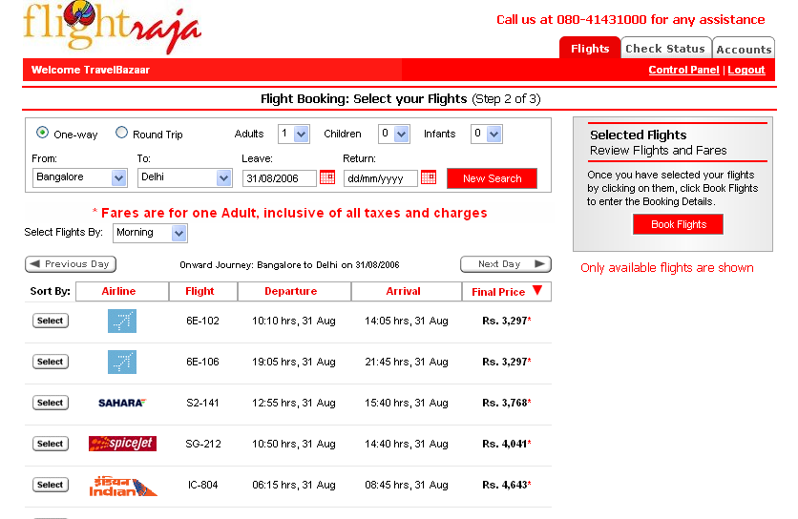
Step 4

Select your Flights. Click Book Flights to continue booking.
Step 5

Fill Passenger Details

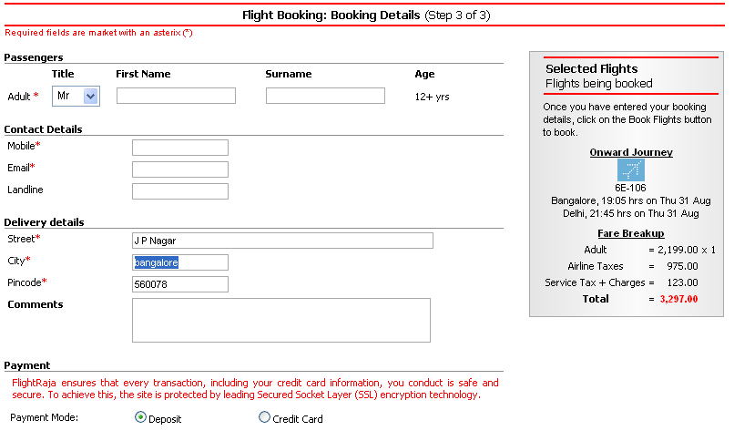
Step 6

Multiple Payment Options to suit the customer needs.

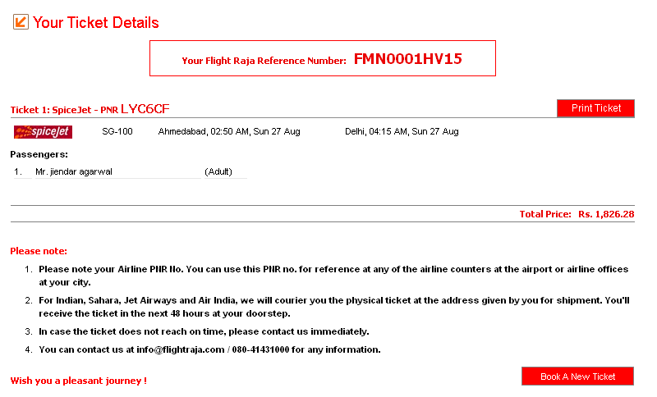
Step 7

Print your ticket.
Control Panel

Access the Agent Control Panel available to the administrator.

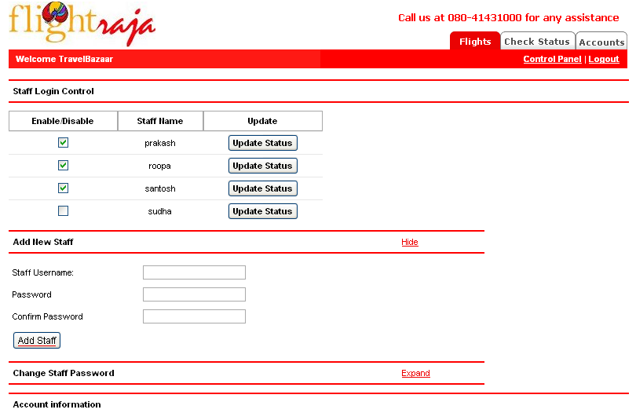
Add Staff

Create individual ids for your staff.
Enable/Disable Staff

Enable and disable your staff at will.

